**Commercial Fruit Farm Inventory and Sales Management System**

**SYSTEM DOCUMENTATION**

**SUBMITTED BY,**

**SIMON NJOROGE KAIRIANJA**

**DSE-01-0122/2023**

**A SYSTEM DOCUMENTATION SUBMITTED IN PARTIAL FULFILMENT FOR THE AWARD OF DIPLOMA IN SOFTWARE ENGINEERING BY ZETECH UNIVERSITY**

**NOV, 2024**

**DECLARATION**

I declare that the contents of this proposal are original and therefore have neither been plagiarized from websites, AI tools, from other student’s work, nor has it been submitted before in a previous semester to Zetech University or any other institution and only contains original work as guided by the unit instructor.

Student Name: ___________________________________ Signature: _____________________

Unit Instructor: ___________________________________ Signature: _____________________

**ACKNOWLEDGEMENT**

I want to thank the unit instructor, Mr. Mutuku Francis, for providing useful insight and change recommendations where I needed personal guidance and Mr. Kennedy my supervisor who also personally guided and assisted me when needed .

**TABLE OF CONTENTS**

1.1 Statement of Problem 1

1.2 Study Justification 1

1.3 System Objectives 1

1.4 Functional Requirements 3

CHAPTER TWO: FRONT END 4

2.1 Introduction to User Interfaces 4

2.2 User Interfaces 4

2.2.1 Sign Up Form 4

2.2.2 Log in Page 6

2.2.3 Dashboard 8

2.2.4 Manage products 10

2.2.5 Sales and Orders 12

2.2.6 Reports 14

CHAPTER THREE: BACK END (DATABASE AND LOGIC) 17

3.1 Introduction 17

3.2 Database implementation 17

3.2.1 Setting up SQL Database 17

3.2.2 Creating and Testing the Tables 17

**3.3 Logic** 23

**3.3.1 Login Functionality** 23

**3.3.2 Signup Functionality** 26

**3.3.3 Dashboard Functionality** 28

3.3.4 Inventory and product management functionality 29

3.3.5 Sales and order functionalities 31

3.3.6 Reports functionalities 33

CHAPTER FOUR: SYSTEM QUALITY TESTS 34

4.1 Introduction 35

4.2 User Entry and Validation Test (Feature Test) 35

4.3 Inventory Update and Auto-Save Test (Feature Test) 35

4.4 Inventory Search and Filter Test (Feature Test) 36

4.5 Database Integration Test: Save and Retrieve Inventory Data 36

4.6 Delete Functionality Test (Feature and DB Test) 37

CHAPTER FOUR: CONCLUSION AND RECOMMENDATIONS 38

Conclusion 38

**Recommendation** 38

**APPENDICES** 39

**Appendix I: Gantt Chart** 39

**Appendix II: Resource Requirement and Economic Feasibility Assessment** 39

**REFERENCES** 40

**ABSTRACT**

The Farm Inventory Management System will manage, trace, and sell the products of Njenga's Fruit Farm efficiently. The system will computerize its present manual record keeping so that the inventory, customer orders, and customer transactions could be maintained properly. The various functionalities provided by this system are adding or editing product details, maintaining quantity in stock, setting an expiration date, and reporting for inventory analysis. It also means easy billing and management of purchase records for the optimization of farm operations. From ease in user interface to power backend processing, the system makes sure that accuracy and efficiency are ensured in operations of inventory and sales of the farm for better use of resources, less wastage, and better decision-making. This system design is scalable, easily extendable to allow the integration of the same with other farm management systems that support business growth.

**LIST OF FIGURES**

Figure 2.2.1-1 sing up form

Figure 2.2.1-2 code for sing up form

Figure 2.2.2-1 log in form

Figure 2.2.2-2 login code

Figure 2.2.3-2 Dashboard code

Figure 2.2.3-1 dashboard form

Figure 2.2.4-1 Manage products page

Figure 2.2.4-2 code for Manage products page

Figure 2.2.5 Sales and Orders page

Figure 2.2.5 code for Sales and Orders page

Figure 2.2.6 Reports page

Figure 2.2.6 code for Reports page

Figure 3.2.2-1 SQL tables created

Figure 3.3.1-1 logic code -DB connection and login validation during login

Figure 3.3.1-2 Error massage incorrect password

Figure 3.3.1-3 error for incorrect user

Figure 3.3.1-3 error message for empty login fields

Figure 3.3.2-1 signup logic code

Figure 23.3.2-2 Signup error for user already exists

Figure 3.3.3-1 Dashboard logic code

Figure 3.3.3-2 search bar results

Figure 3.3.3-4 inventory count

Figure 3.3.4-1 logic code for product and inventory management

Figure 3.3.4-2 add and editing products

Figure 3.3.5-1 logic code for sales and orders

Figure 3.3.5-2 sale and receipt printing

Figure 3.3.6-1 logic code for reports generation

Figure 33.3.6-2 logic code for report printing

Figure 3.3.6-3 reports selection

**LIST OF TABLES**

Table 1.4 Functional Requirements Table

Table 3.2.2-1 users table

Table 3.2.2-2 products table

Table 3.2.2-3 orders table

Table 4.5-1 data saved automatically

Table 4.6 Summary of tests

**ABBREVIATIONS AND ACRONYMS**

**PHP:** Hypertext Preprocessor

**DB:** Database

**FK:** Foreign Key

**INT:** Integer

**PK:** Primary Key

**SQL:** Structured Query Language

**VARCHAR:** Variable Character Field

**DEFINITION OF KEY TERMS**

**Coordinator:** A user role in the system responsible for managing the system.

**Dashboard:** A user interface panel where users can view and manage different aspects of the system.

**Database (DB):** An organized collection of data stored and managed electronically, often in a relational structure with tables and fields.

**Foreign Key (FK):** A field in a database table that links to a primary key in another table, establishing a relationship between the two tables.

**Front-End:** The part of the system that interacts with the user, including graphical interfaces and input fields.

**Login Page:** The entry interface of the system where users provide credentials to access the system.

**Primary Key (PK):** A unique identifier for each record in a database table.

**Structured Query Language (SQL):** A standardized programming language used for managing and querying relational databases

**CHAPTER ONE: SYSTEM OVERVIEW**

## 1.1 Statement of Problem

Peter Njenga has a commercial farm growing fruits of different kinds – bananas, mangoes, watermelons, passion fruit, avocado, etc. He sells mostly on wholesale. He wants an effective way of recording everything he buys for the business and also to bill customers when a sale is made, without having to manually record in a book.

## 1.2 Study Justification

Fruit farming is becoming increasingly complex due to the diverse types of fruits, modes of transactions, and expanded sizes of operations. Inventory and customer sales up until today are recorded with classic methodologies of ledger books and spreadsheets; similarly, so is billing. These traditional systems are extremely time-consuming, full of errors, and enormously deterring productivity; thus, they stand in the way of effectively managing the farm.

It is hereby concluded that with regard to the inventory management, bills processing, and updating the stocks on hand and customer's transaction, the computerized system would be very helpful on a real-time basis. Efficiency in terms of data entry, avoidance of human errors, and correct decision making in no time, this would thus enable the business to carry on its running in profitable ways stiff competition. Besides, automation of processes would lead to efficiencies in all processes, ensure an optimum utilization of the available resources, and achieve better cash flow management by way of accurate tracking of the payments made and the balance outstanding.

In this regard, there is a rationale for the development of a computerized inventory and sales management system to take the place of manual processes in operation, which are labor-intensive and inefficient. The system is bound to increase productivity, customer satisfaction, and ensure sustainable profitability for commercial fruit farms.

## 1.3 System Objectives

* + 1. **General Objective**

1. Effective Inventory Control, Sales Management, and Operational Effectiveness
   * 1. **Specific Objectives**
2. Automated Billing: Create an automated billing system to generate invoices for wholesale customers immediately after a sale is made.
3. Customer Relationship Management (CRM): Integrate a CRM module to manage customer data, order history, and preferences, enhancing customer service and repeat sales.
4. Payment Tracking: Develop a feature that tracks customer payments and outstanding balances, reducing the risk of errors and improving cash flow management.
5. Real-time Inventory Tracking: Implement a system that provides real-time updates on inventory levels for all types of fruits grown (bananas, mangoes, watermelons, passion fruit, avocados, etc.).

## 1.4 Functional Requirements

|  |  |  |
| --- | --- | --- |
| **User** | **User Activities** | **Features** |
| Shop owner | * Sing up | Sing up form |
|  | * log in | Log in form |
|  | * dashboard | Dashboard with the following sections:  Product search bar  Product count  Inventory count  Orders count  Sales count  Manage products  Inventory tracking  Sales and orders  Generate reports |
|  | * manage products * inventory tracking | Add products  Edit products  View inventory |
|  | * sales and orders | Choose product  Add order  Print receipt |
|  | * Generate reports | Select report type  Print report |

*Table 1.4 Functional Requirements Table*

## CHAPTER TWO: FRONT END

**(USER INTERFACES)**

## 2.1 Introduction to User Interfaces

## 2.2 User Interfaces

## 2.2.1 Sign Up Form

This is the form were new users will register their details:

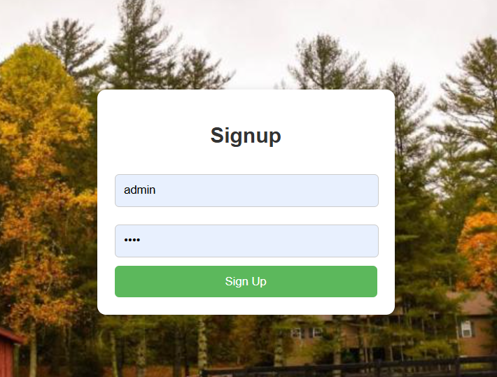

Figure 2.2.1-1 sing up form

This is the code that generated the above:

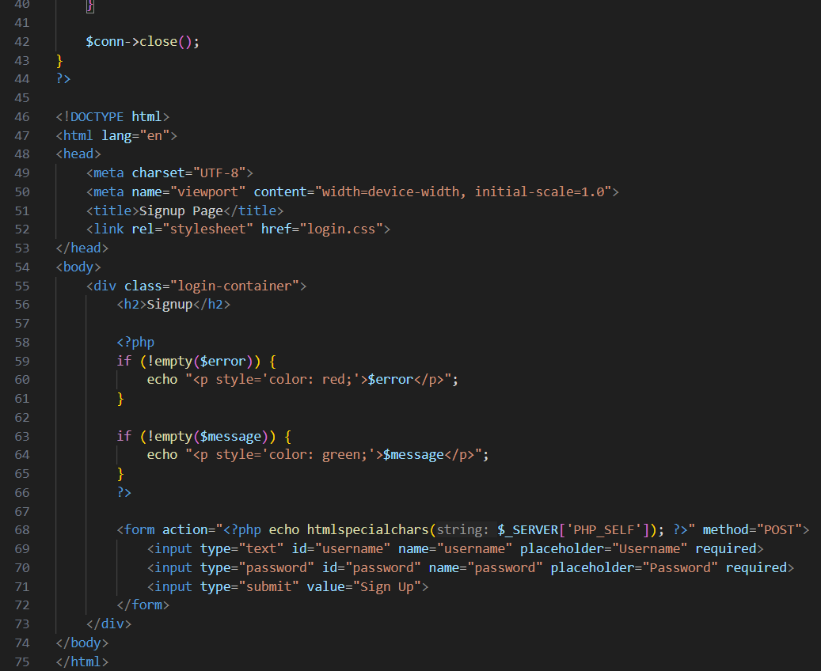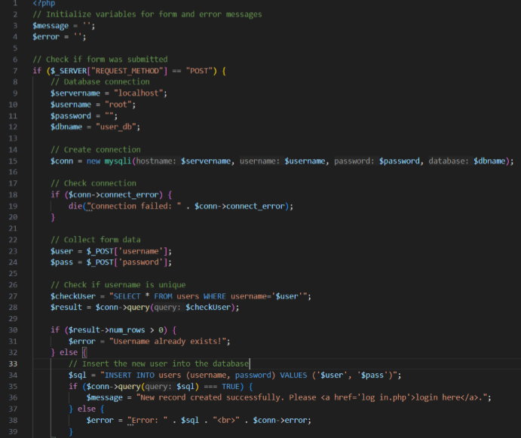

Figure 2.2.1-2 code for sing up form

## 2.2.2 Log in Page

This will be used by all the users to access the system and is the default window that pops up when the application is launched

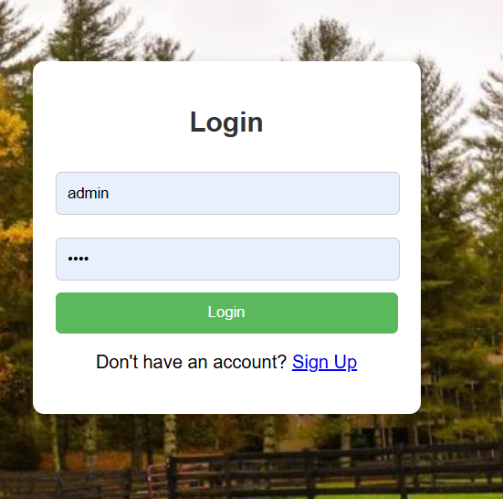

Figure 2.2.2-1 log in form

Below is the php code from the *Login.ph* that has generated the page above:

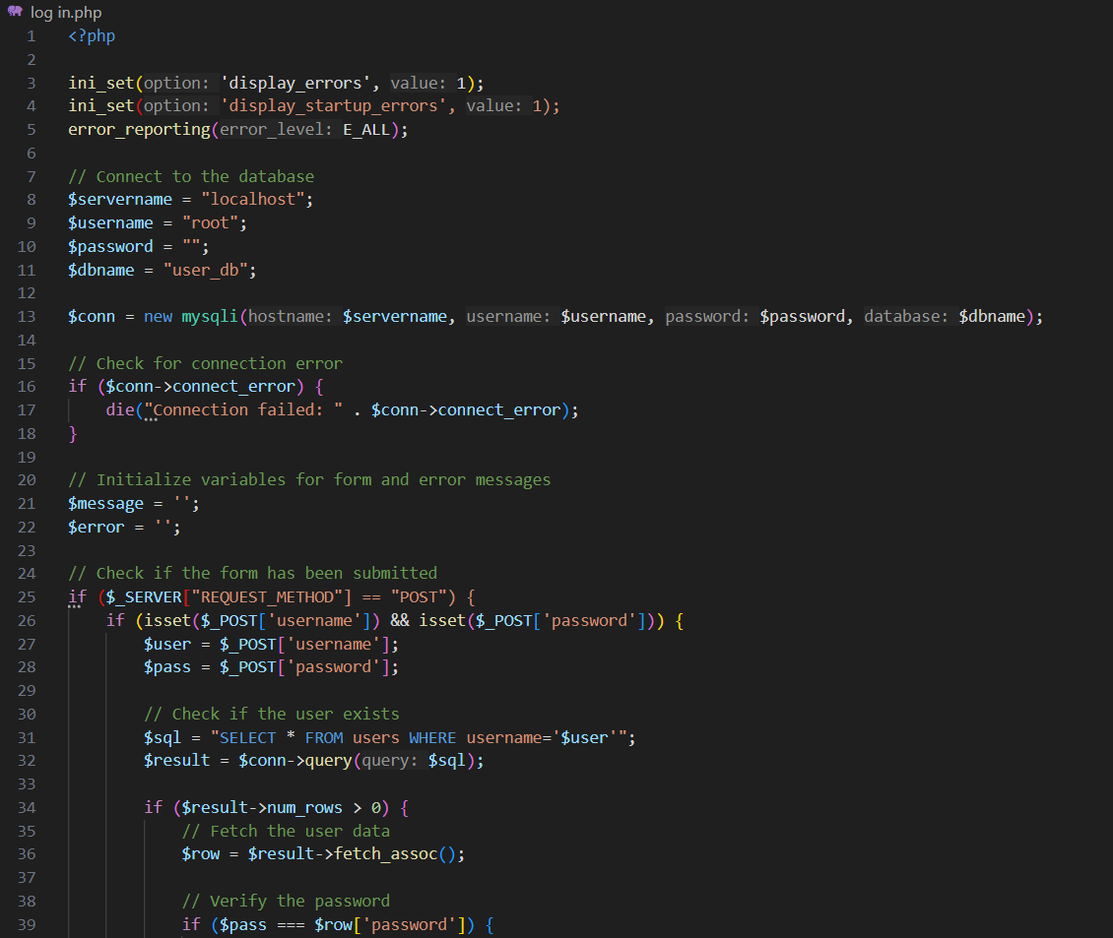

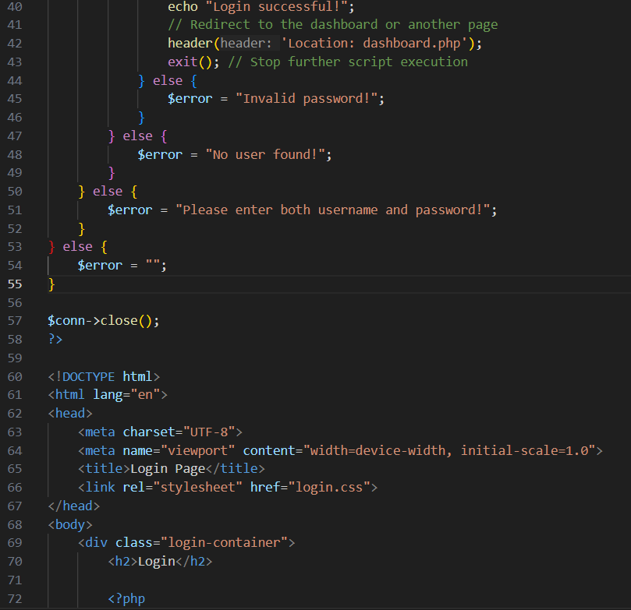

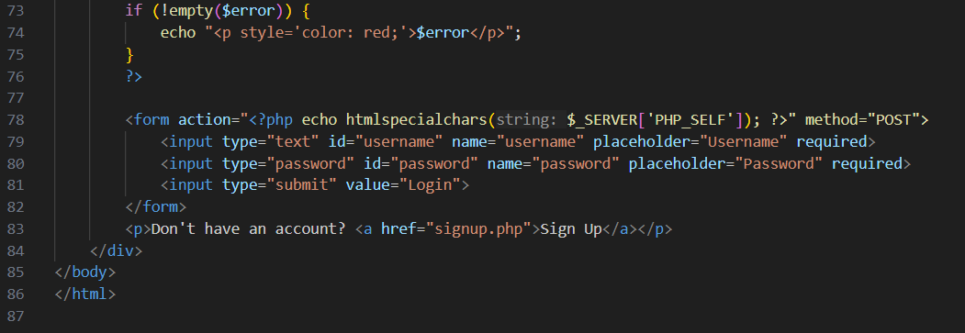

Figure 2.2.2-2 login code

2.2.2-2 code for log in form

## 2.2.3 Dashboard

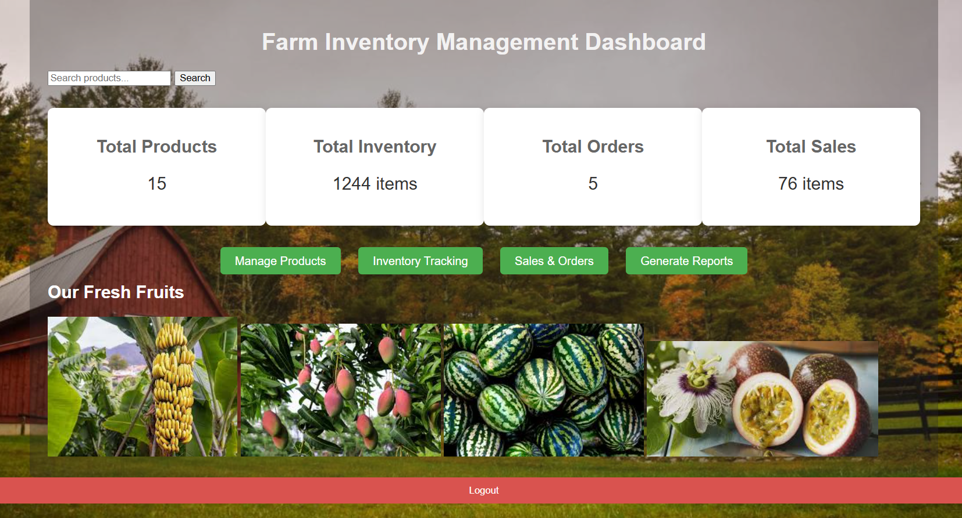

Figure 2.2.3-1 dashboard form

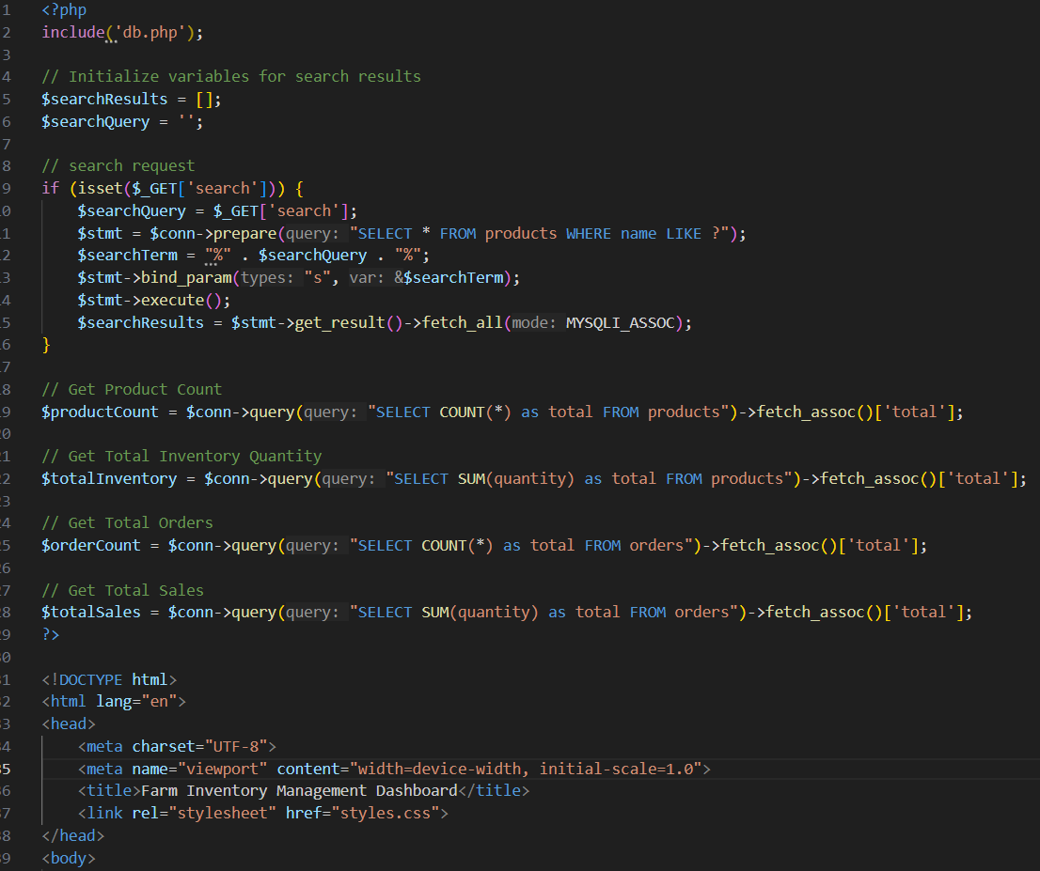

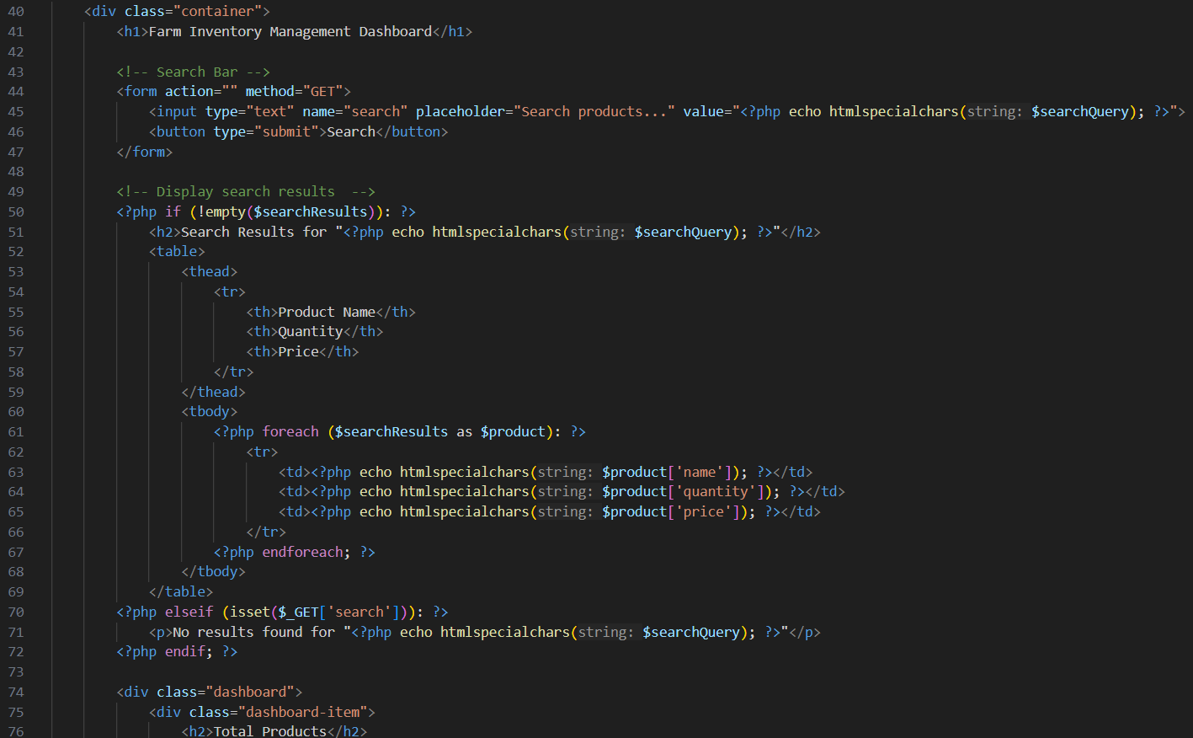

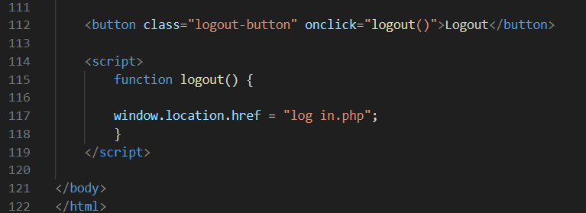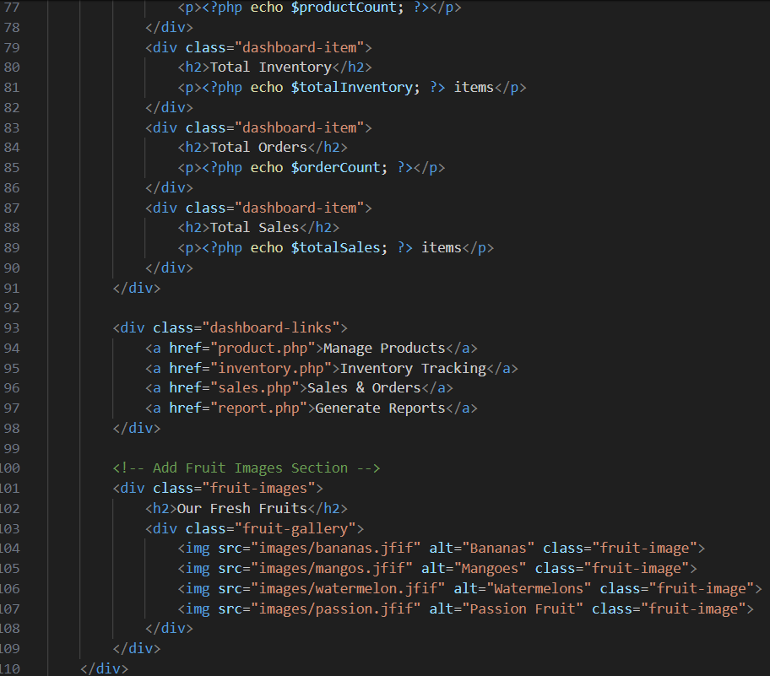

Figure 2.2.3-2 Dashboard code

## 2.2.4 Manage products

This were all products will be managed and adde

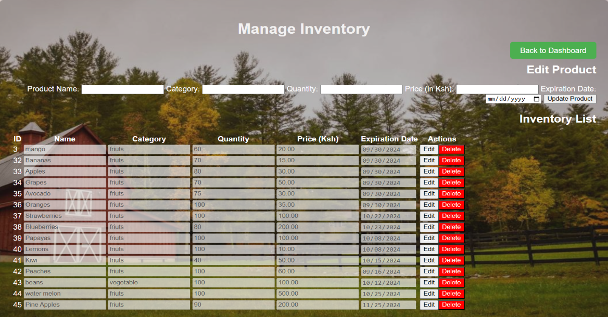

Figure 2.2.4-1 Manage products page

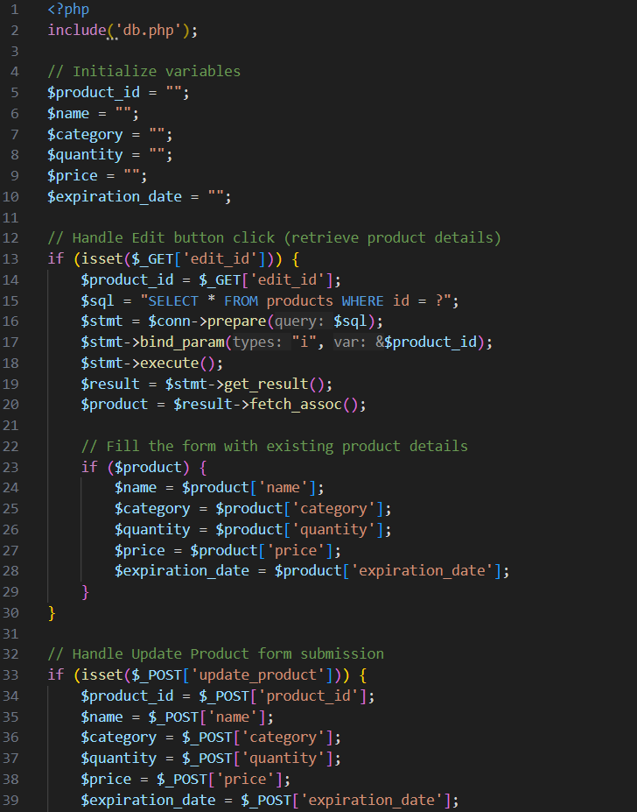this is the code that generated the above

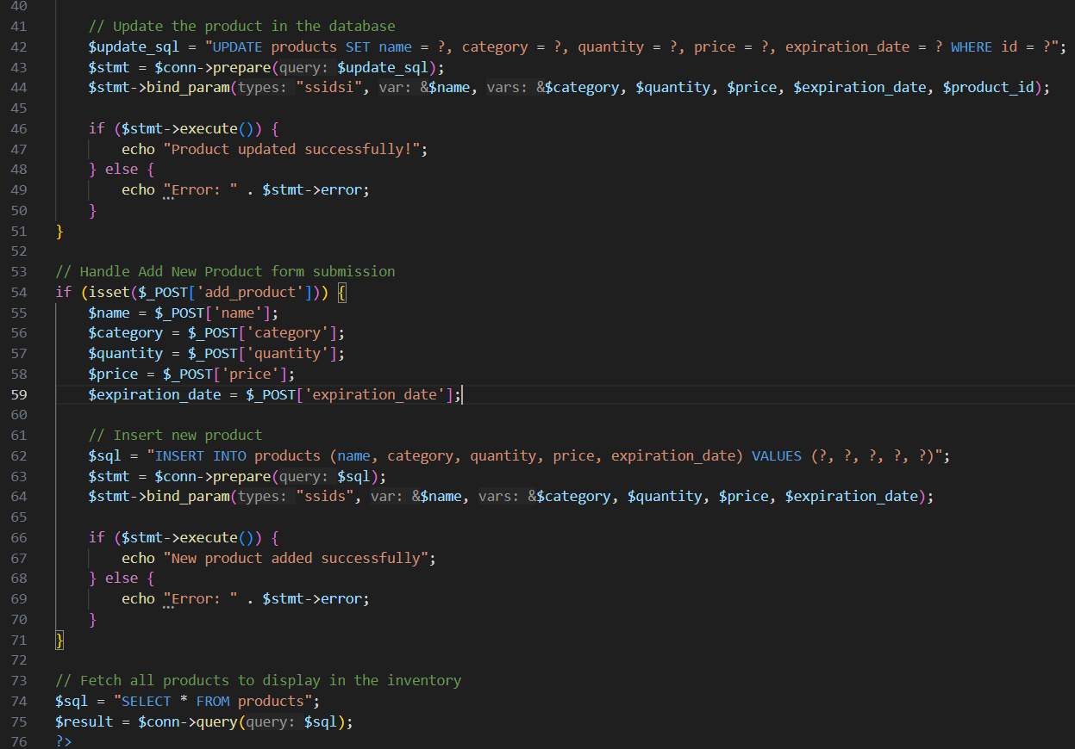

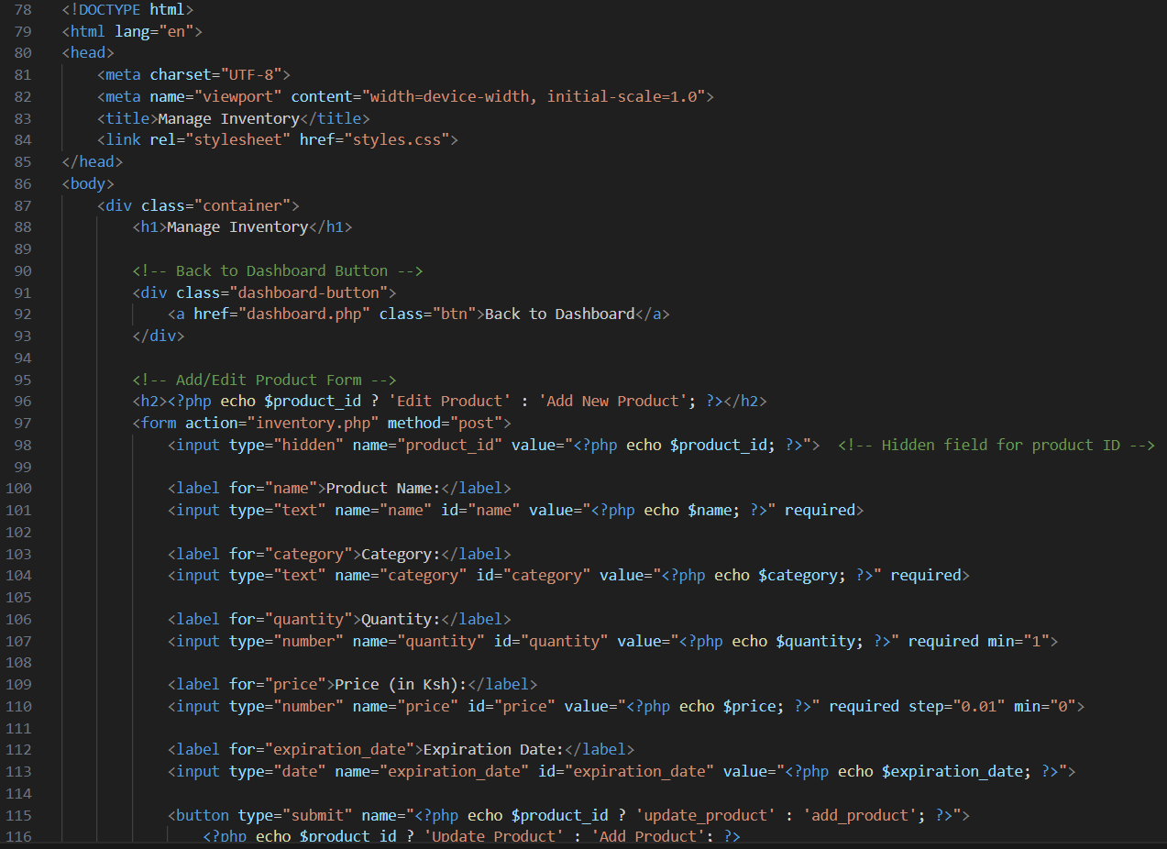

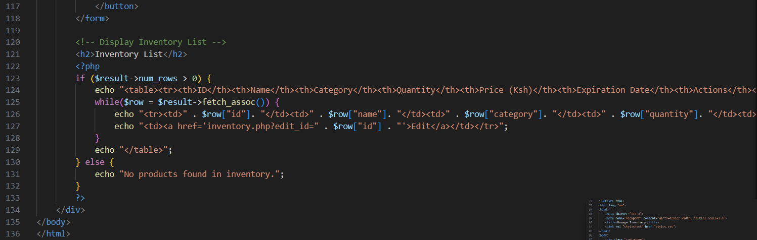

Figure 2.2.4-2 code for Manage products page

## 2.2.5 Sales and Orders

This is where sales and order will be processed

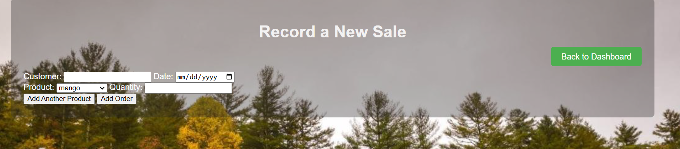

Figure 2.2.5 Sales and Orders page

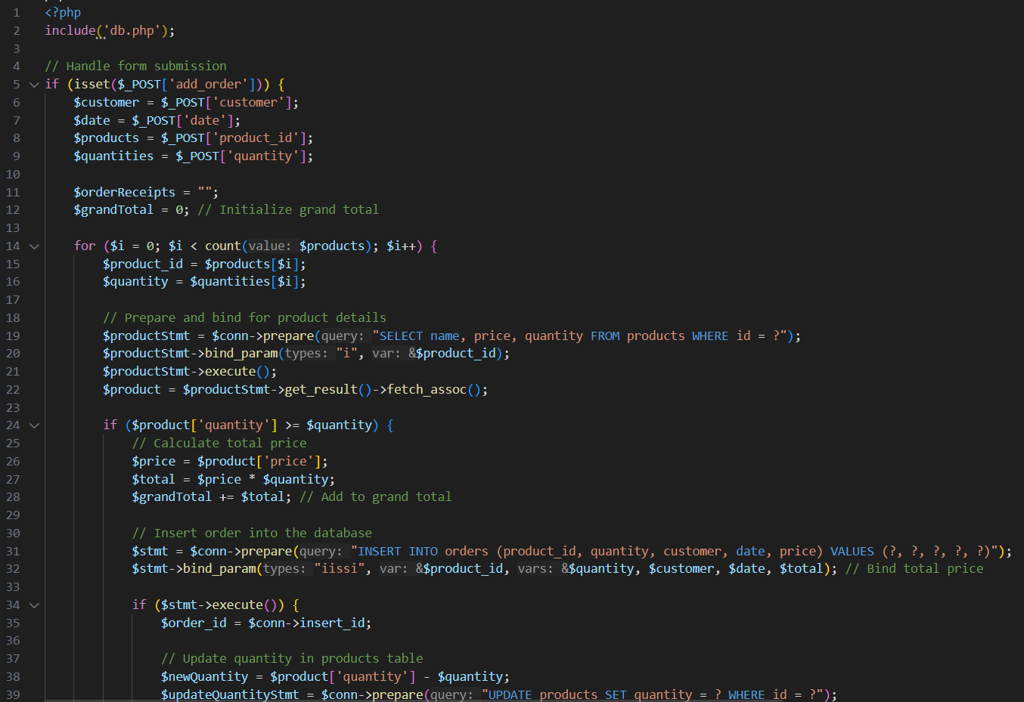

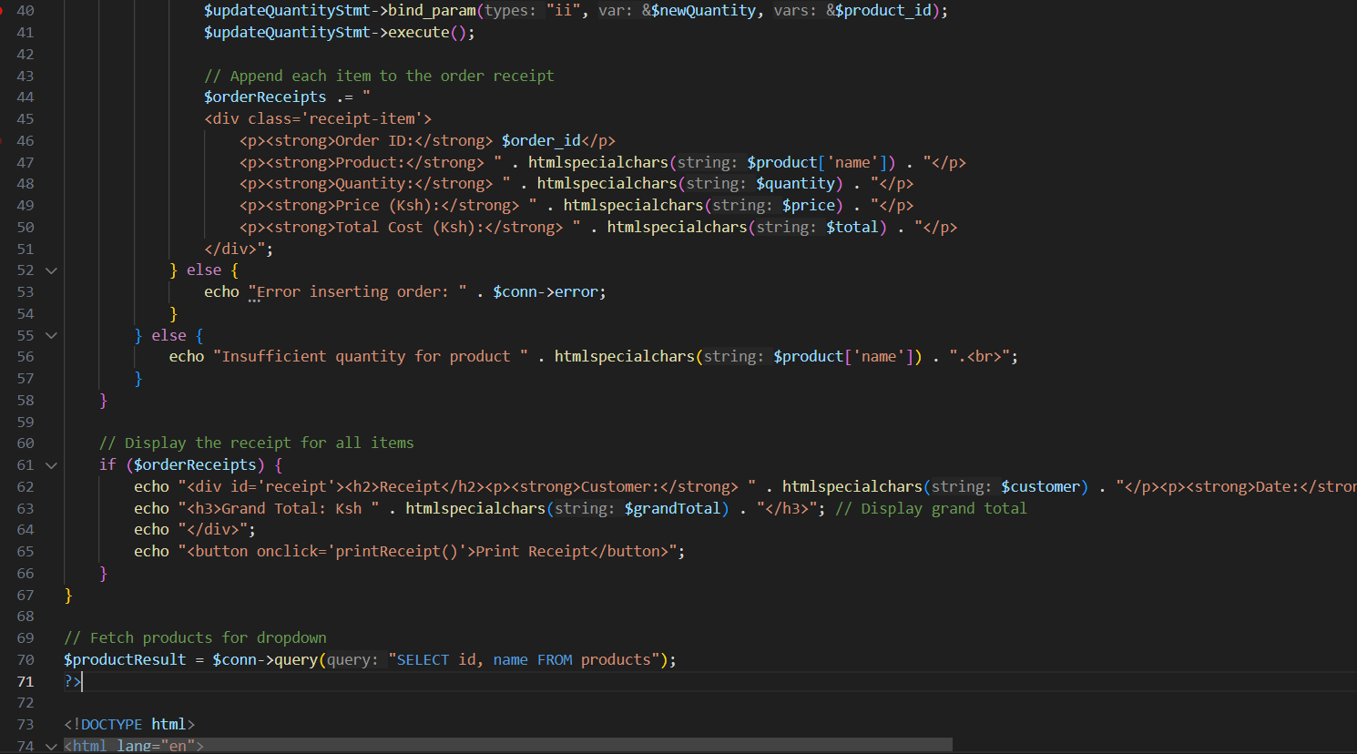

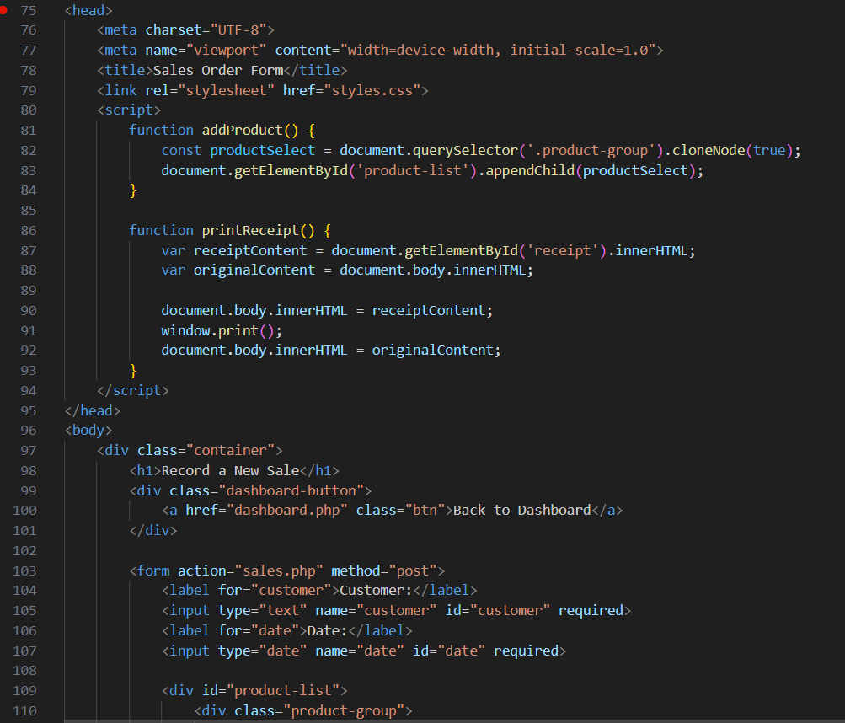

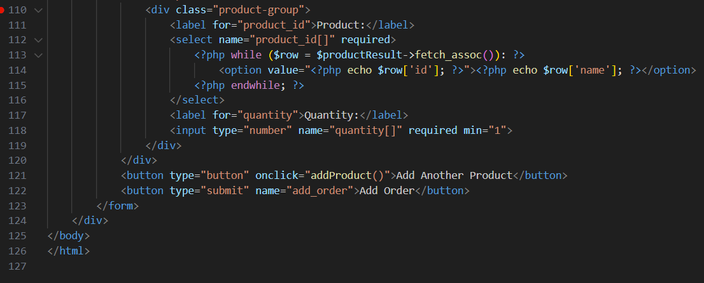

Figure 2.2.5 code for Sales and Orders page

## 2.2.6 Reports

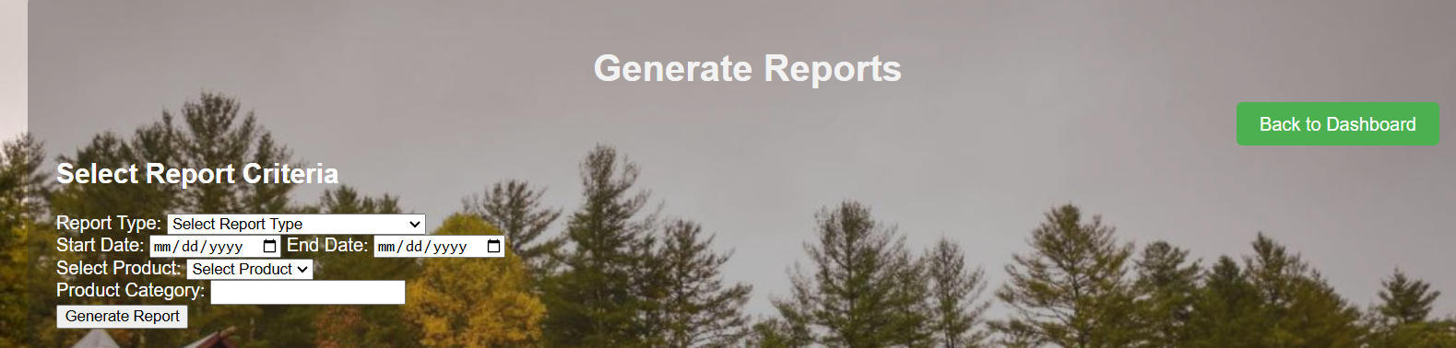

Figure 2.2.6 Reports page

This code is responsible for the reports page:

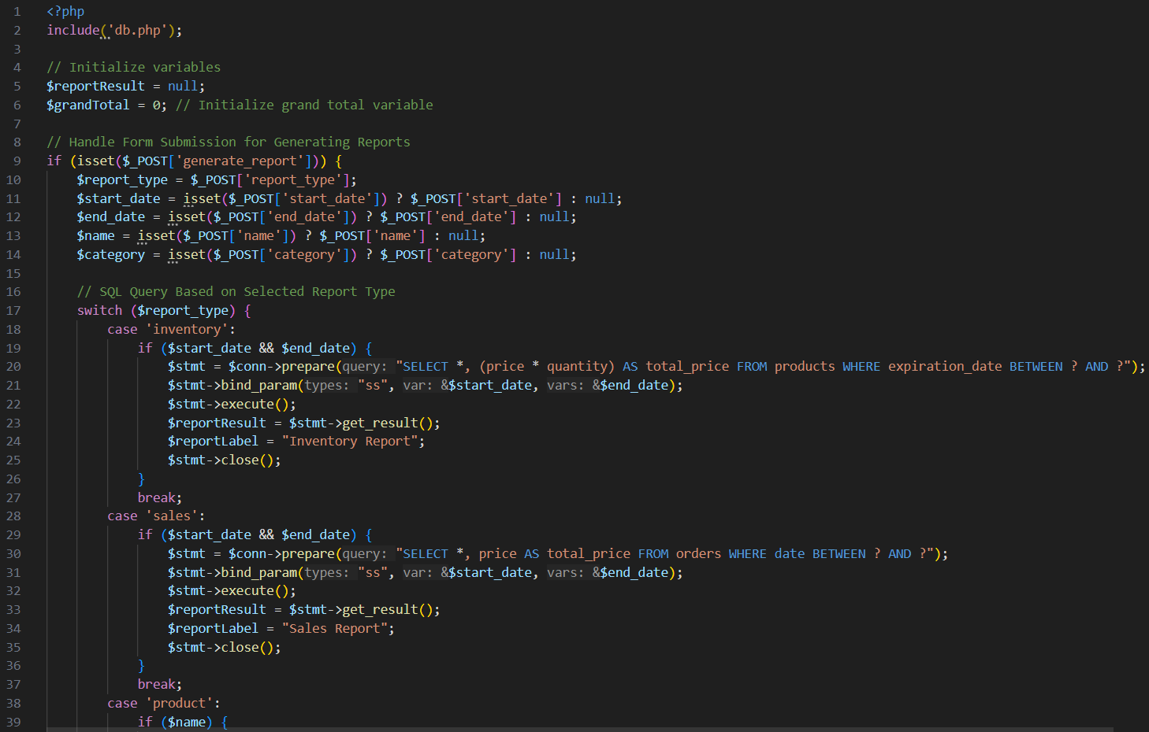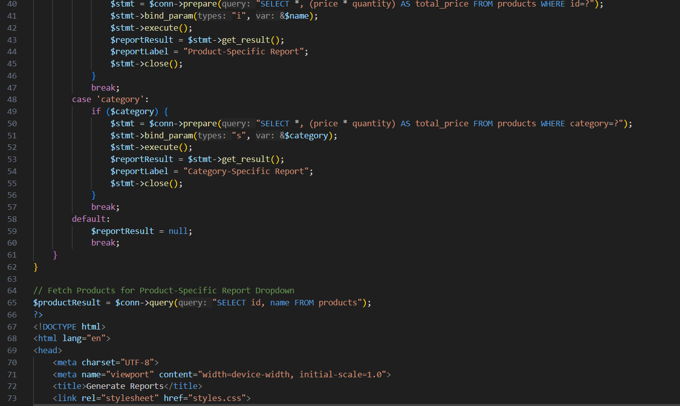

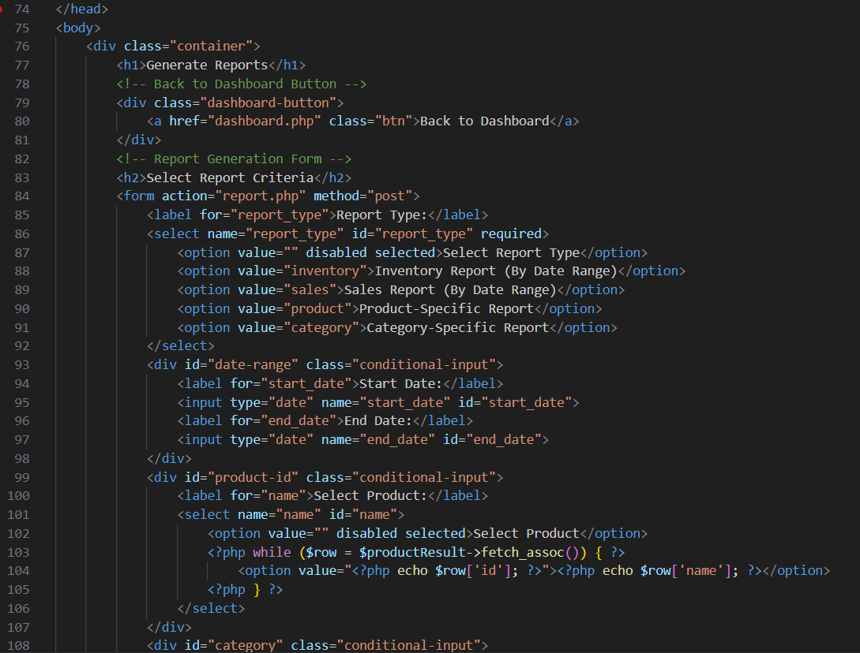

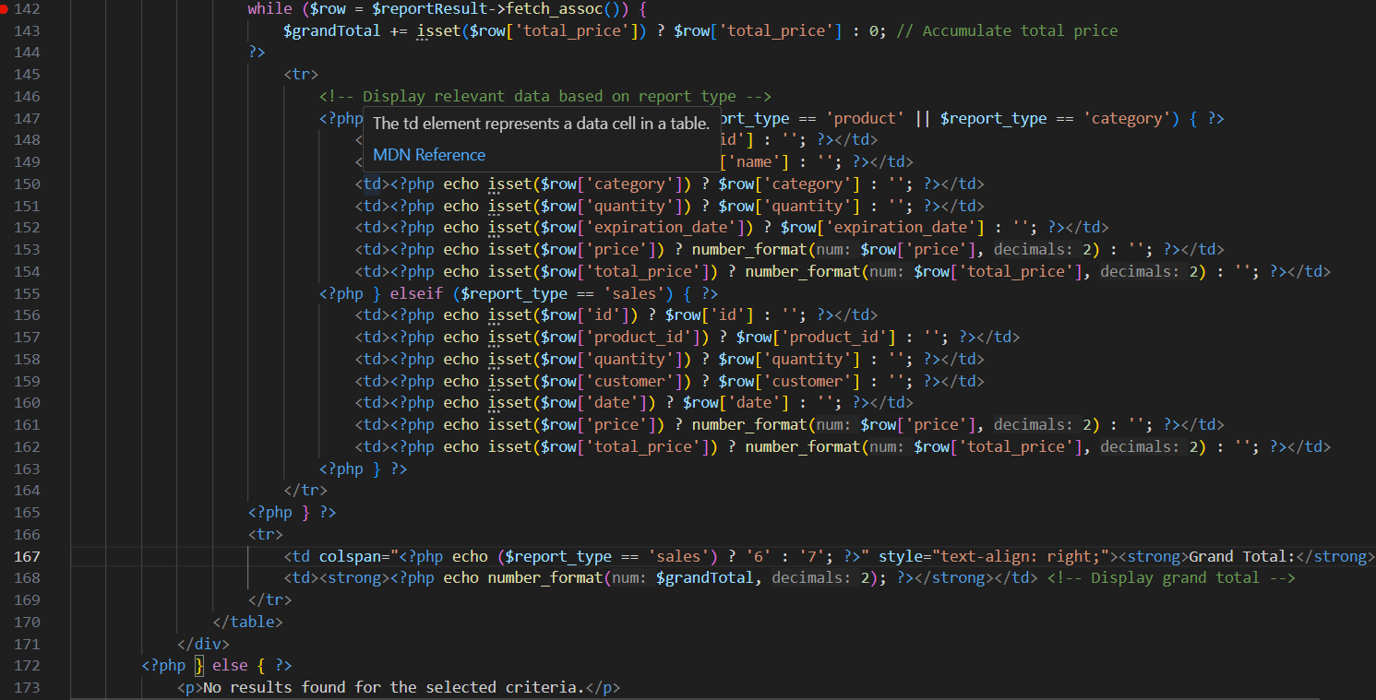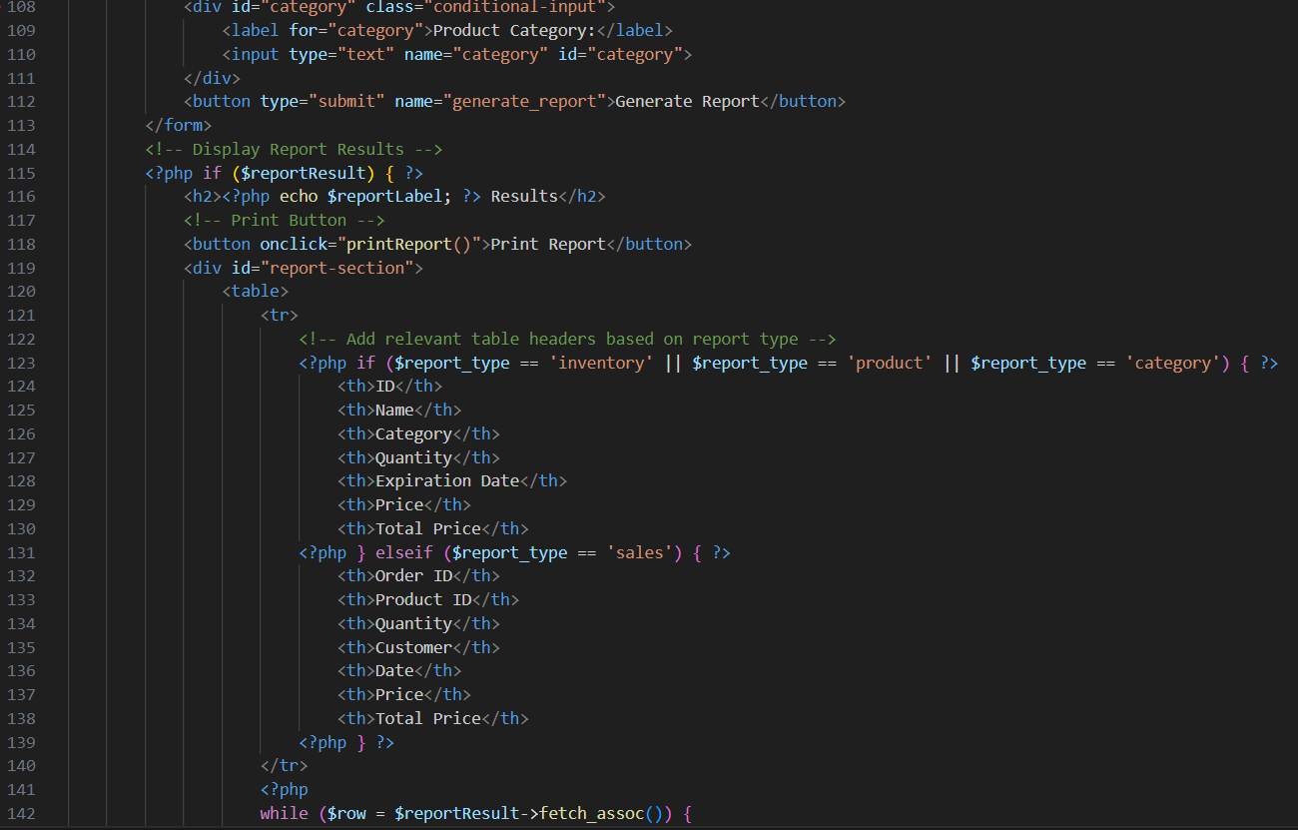

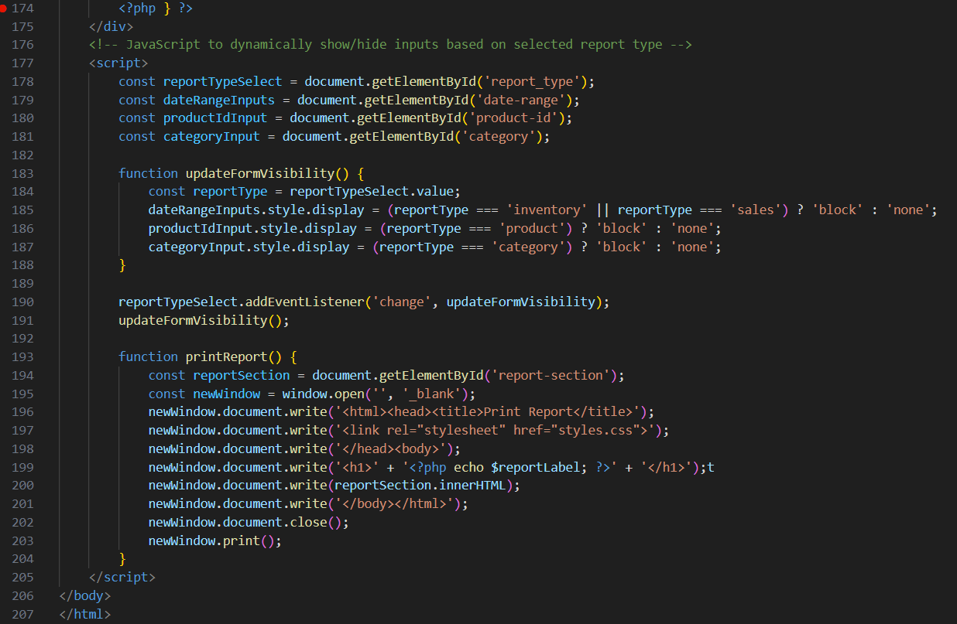

Figure 2.2.6 code for Reports page

## CHAPTER THREE: BACK END (DATABASE AND LOGIC)

## 3.1 Introduction

This chapter focuses on the implementation of database (for data storage and retrieval) and back-end code (ensuring interactivity of the system)

## 3.2 Database implementation

Implementation has been done using SQL, implemented with XAMPP where all other aspects of the development of the system has been done. SQL was used since it would offer better, more structured organization for data that is easy to manage as the data will be well organized in tables which can share the data consistently.

## 3.2.1 Setting up SQL Database

1.Install XAMPP.

The process began with the installation of XAMPP, is an open-source software package that provides a local web server environment for testing and development it comes with SQL already installed

Open the XAMPP Control Panel.

Start the Apache and MySQL modules.

2. Access phpMyAdmin

Go to http://localhost/phpmyadmin in your browser.

Create a database for your project:

Click New on the left panel.

Enter the database name (e.g., fruit_farm).

Click Create.

## 3.2.2 Creating and Testing the Tables

All data in the system is stored in a relational SQL database where fundamentally tables are the host sites for data. The following steps were taken to create and test the validity of the tables

*Step 1: Data Normalization*

Normalization was performed to organize the data into tables that reduce redundancy, avoid data anomalies, and ensure consistency. It involves applying three normal forms (1NF, 2NF, 3NF) to the raw data.

*1NF (First Normal Form)*

The data was organized into rows and columns with atomic (indivisible) values. Repeating groups were removed.

*Raw Data:*

Username, password, price, quantity, customer, price, date, category, expiration date, name, product

*Tables Identified:*

orders: fields (id, product_id, quantity, customer, date, price).

products: fields (id, name, category, quantity, expiration_date, price).

users: fields (id, username, password).

*2NF (Second Normal Form)*

All non-key attributes should fully depend on the primary key-no partial dependencies.

Primary Key Analysis:

orders:

The primary key is id.

Non-key attributes, product_id, quantity, customer, date and price, depend directly on id.

No partial dependencies.

products:

The primary key is id.

Non-key attributes, name, category, quantity, expiration_date and price depend directly on id.No partial dependencies.

users:

The primary key is id.

Non-key attributes, username and password, depend directly on id.

No partial dependencies.

*3NF (Third Normal Form)*

Transitive dependencies were removed. Non-key attributes now depend only on the Primary Key.

*Final Tables and Relationships*

*1. Users Table*

Stores login credentials and user details

|  |  |  |
| --- | --- | --- |
| **Field** | **Data type** | **Constraint** |
| Id | INT | Primary key |
| username | VARCHAR(255) | Not null |
| password | VARCHAR(255) | Not Null |

Table 3.2.2-1 users table

*2. Products Table*

Stores information about products (name, category, quantity, price, expiration date)

|  |  |  |
| --- | --- | --- |
| **Field** | **Data type** | **Constraint** |
| Id | INT | Primary key |
| Name | VARCHAR (50) | Not Null |
| Category | VARCHAR (50) | Not Null |
| Quantity | INT | Check (11) |
| Epiration_date | DATE | Not Null |
| Price | DECIMAL | Check (10,2) |

Table 3.2.2-2 products table

*3. Orders tables*

Stores information about orders (product_id, quantity, customer, date, price)

|  |  |  |
| --- | --- | --- |
| **Field** | **Data type** | **Constraint** |
| Id | INT | Primary key |
| Product_id | INT | Foreign key |
| Customer | VARCHER (50) | Not null |
| Date | DATE | Not null |
| Price | DECIMAL | Check (10,2) |
| quantity | INT | Not null |

Table 3.2.2-3 orders table

*Step 3: Relationships*

One-to-Many Relationship:

|  |
| --- |
| Products |
| Id (pk) |
| Name |
| Category |
| Quantity |
| Epiration_date |
| Price |

A product (products.id) can be part of multiple orders (orders.product_id).

|  |
| --- |
| Users |
| Id (pk) |
| Username |
| password |

|  |
| --- |
| Orders |
| Id (pk) |
| Product_id (fk) |
| Customer |
| Date |
| Price |
| Quantity |

*Step 4: Creating Tables in XAMPP*

The following steps were taken to create the tables in XAMPP Database.

Click on the name of your database in the left sidebar.

Click "Create Table".

Provide a table name (e.g., orders).

Specify the number of columns (e.g., 6 for orders).

Define Columns

For each column, enter:

Name: Column name (e.g., id, product_id, quantity).

Type: Data type (e.g., INT, VARCHAR, DATE).

Length: Maximum length (if applicable, e.g., 50 for VARCHAR).

Attributes: Any extra properties like UNSIGNED.

Primary Key: Select the checkbox for id.

Auto Increment: For primary keys, check A_I (Auto Increment).

Click Save to create the table.

To create a table in XAMPP, follow these steps:

Step 1: Start XAMPP

Open the XAMPP Control Panel.

Start the Apache and MySQL modules.

Step 2: Open phpMyAdmin

Open a web browser and go to http://localhost/phpmyadmin.

phpMyAdmin will load, allowing you to interact with your MySQL databases.

Step 3: Create a Database (if not already created)

Click on the "New" option in the left sidebar to create a new database.

Enter a name for your database (e.g., farm_inventory).

Choose a collation (e.g., utf8mb4_general_ci) and click Create.

*Step 4: Create Tables*

Click on the name of your database in the left sidebar.

Click "Create Table".

Provide a table name (e.g., orders).

Specify the number of columns (e.g., 6 for orders).

Define Columns

For each column, enter:

Name: Column name (e.g., id, product_id, quantity).

Type: Data type (e.g., INT, VARCHAR, DATE).

Length: Maximum length (if applicable, e.g., 50 for VARCHAR).

Attributes: Any extra properties like UNSIGNED.

Primary Key: Select the checkbox for id.

Auto Increment: For primary keys, check A_I (Auto Increment).

Click Save to create the table.

Example SQL Query for Table Creation

Alternatively, you can use SQL queries in phpMyAdmin:

Click on your database name.

Go to the SQL tab.

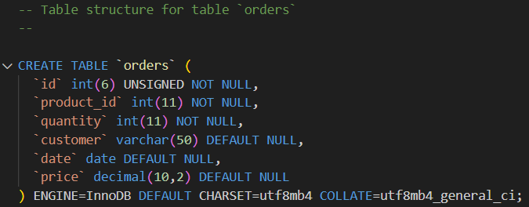Enter the following SQL to create a table

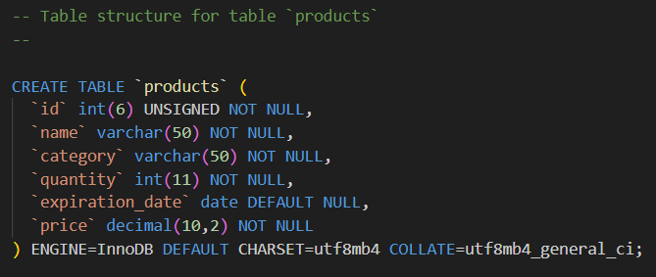

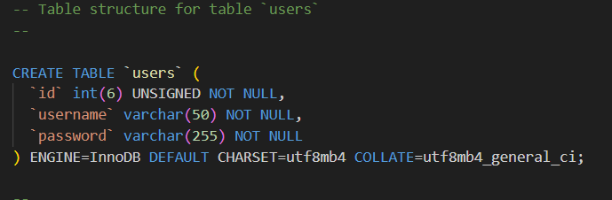

Figure 3.2.2-1 SQL tables created

**3.3 Logic**

This is the backend code that makes the system interactive e.g. data can be correctly saved, and retrieved, buttons are working correctly, inputs and outputs are possible, etc.

The following are samples of logic for different features and functionalities of the system:

**3.3.1 Login Functionality**

When Peter of one of his workers enters there login details the login functionality performs authentication of a user against a database by using a username and password. Once a form is submitted through POST, the code fetches the username and password values from the input fields of the form and executes a query to check if there is any user with the provided username in the user’s database.

If the user is found, it directly compares the entered password to the password stored in the database. If the passwords match, it shows a "Login successful!" message before redirecting the user to the dashboard.php page. In case of a wrong password or if no matching user could be found, an error message should appear.

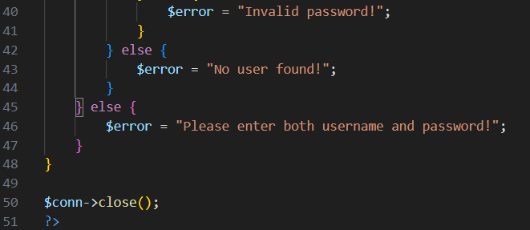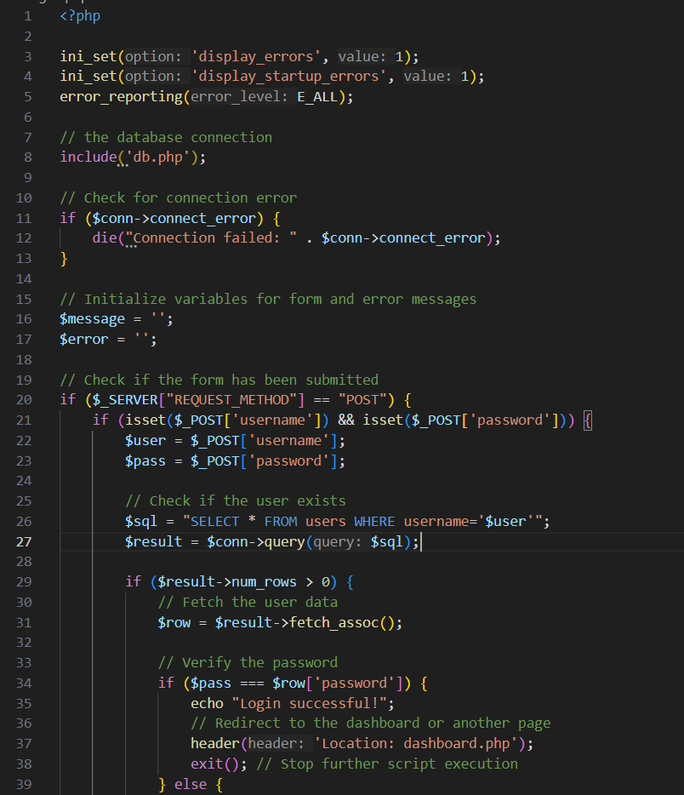hch

Figure 3.3.1-1 logic code -DB connection and login validation during login

If the password is incorrect, the following error message will pop up:

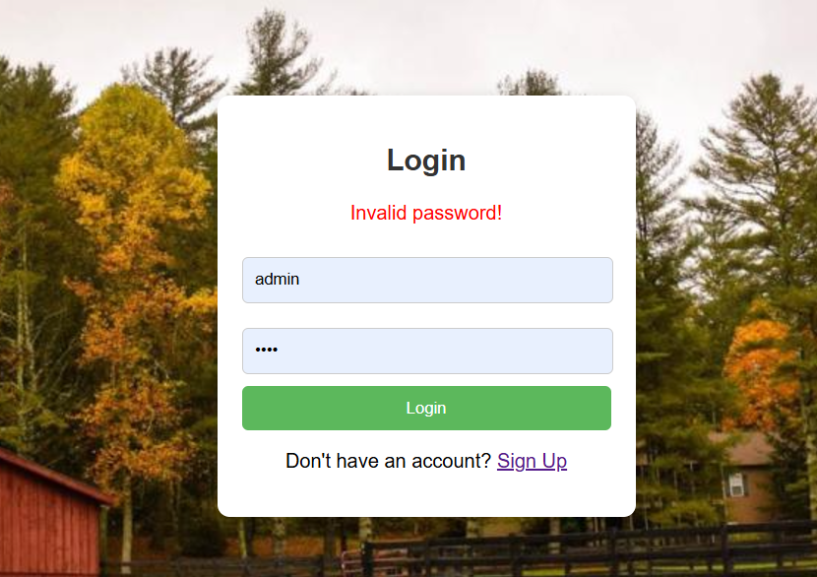

Figure 3.3.1-2 Error massage incorrect password

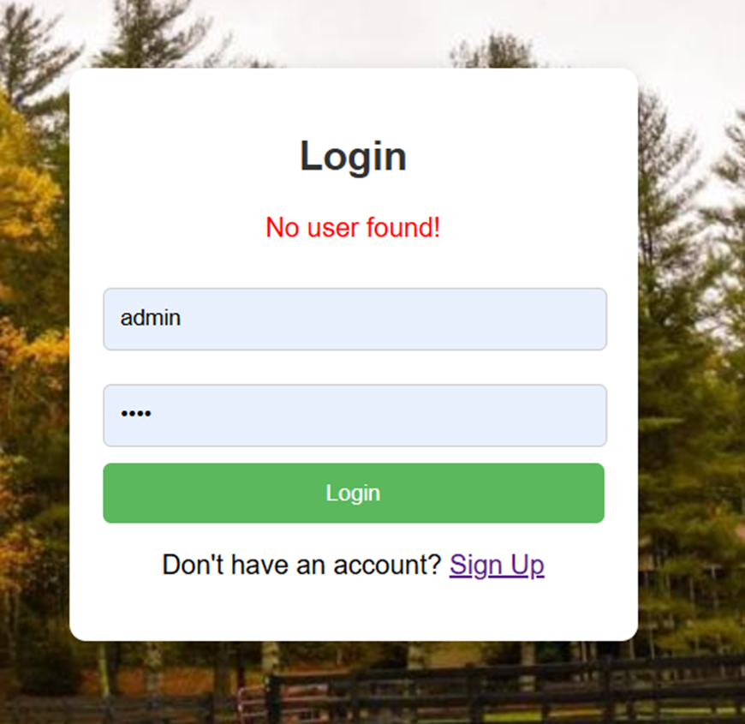If the username is incorrect, the following error message will pop up:

Figure 3.3.1-3 error for incorrect user

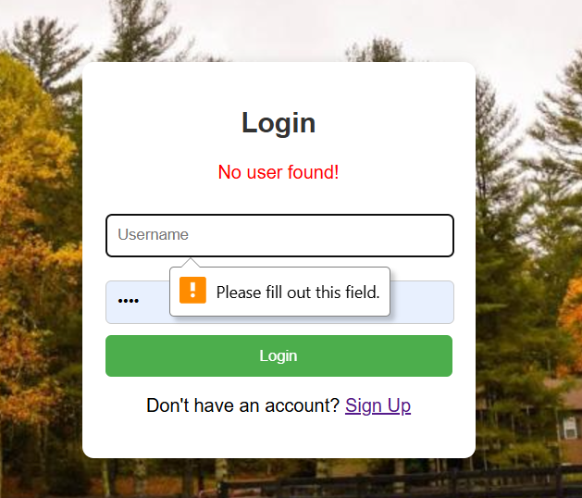If there are empty fields, the following error message will pop up, this applies to all fields:

Figure 3.3.1-3 error message for empty login fields

**3.3.2 Signup Functionality**

When peter wants to add a new account on the system he would click on the signup link which will lead him to the signup page. When the form is submitted using the method POST, it opens a connection to the database first, using credentials from an included file db.php. After that, the script will collect the entered username and password, then check if such a username already exists in the database to make sure it's unique. If it does, an error message is returned to notify a user that this username is already in use. This script will insert a new record into the database with the given credentials, provided that the username is unique. If the registration is successful, a success message is displayed, offering a link to the login page. Finally, it closes the connection to the database, freeing the resources.

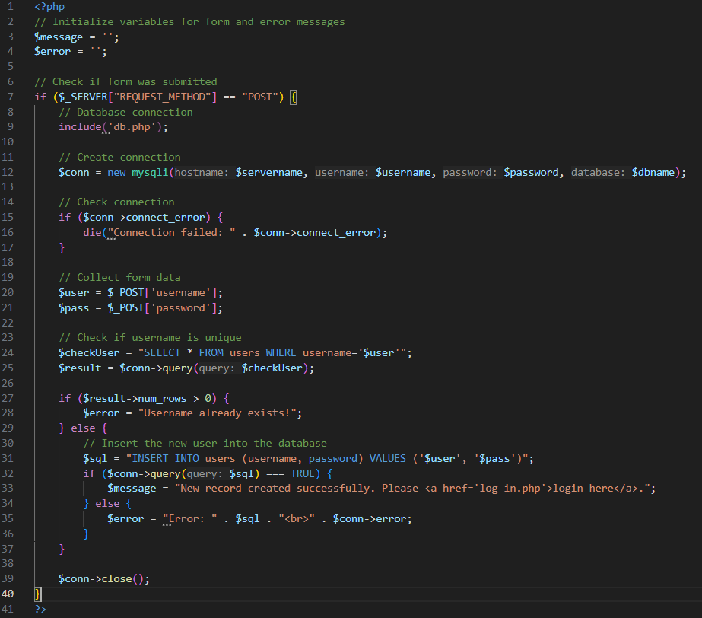

Figure 3.3.2-1 signup logic code

The following error will appear when coordinator attempts to add users name that already exists

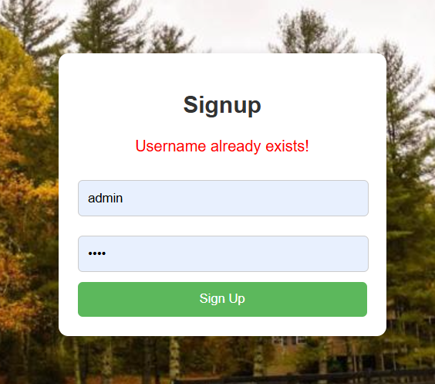

Figure 3.3.2-2 Signup error for user already exists

**3.3.3 Dashboard Functionality**

The Farm Inventory Management Dashboard offers the necessary features for tracking and managing sales and inventory information. It uses a search box to enable visitors to look for goods by name and links to a database (db.php). The search function uses prepared statements. It then extracts relevant results from the products table and presents them in a structured table together with information like the product name, quantity, and price. Furthermore, the code computes and shows important inventory metrics that are dynamically retrieved from the database, such as the total number of goods, the total number of items in inventory, the total number of orders, and the total sales volumes.

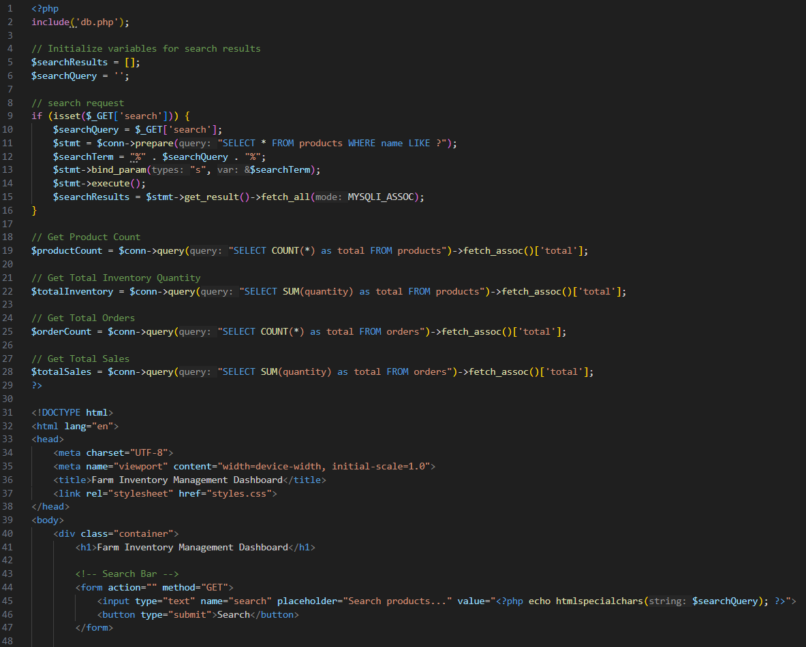

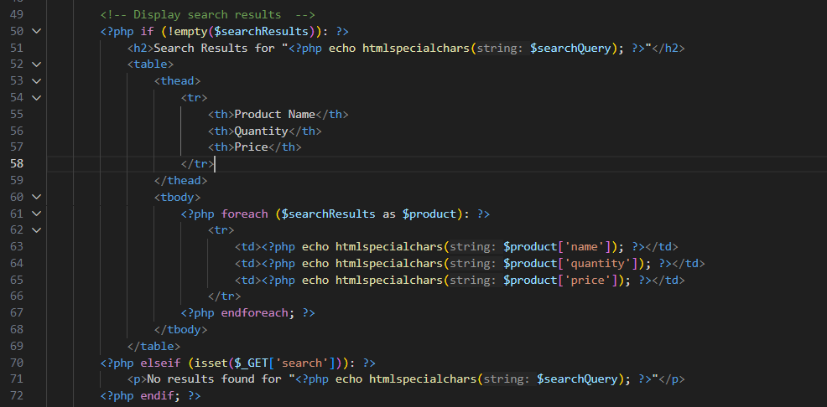As peter or one of his workers search for any product they will be displayed in the following 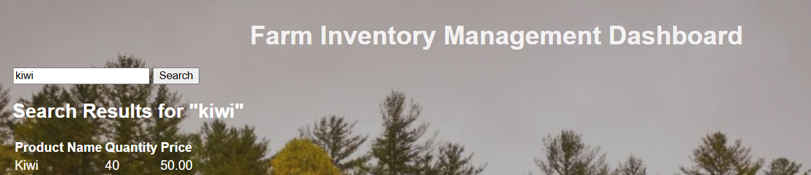ways:

Figure 3.3.3-1 Dashboard logic code

Figure 3.3.3-2 search bar results

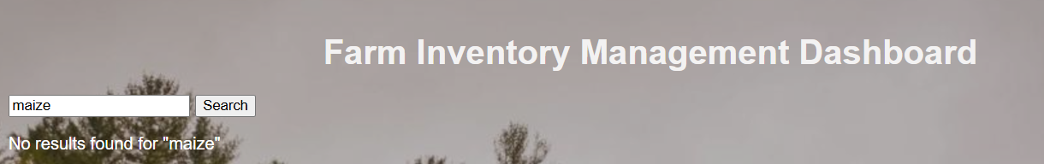The following is the error massage for item not found:

Figure 3.3.3-3 error for item not found

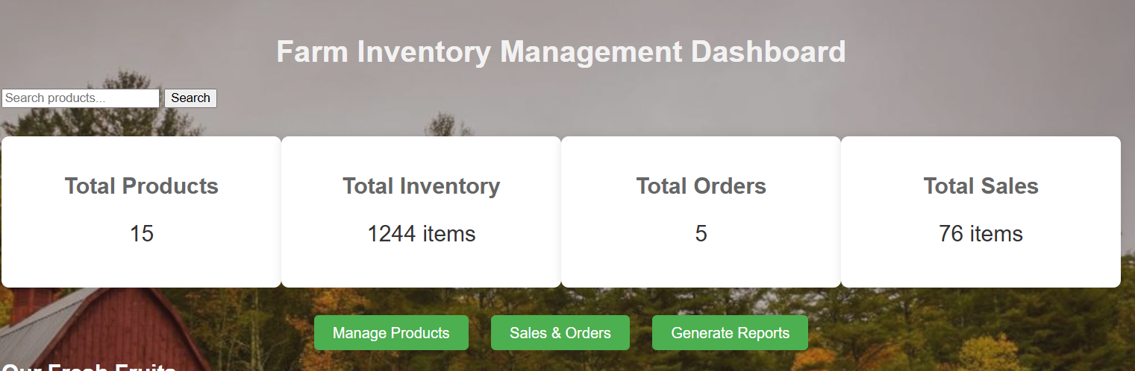The following is the display of inventory count on the dashboard:

Figure 3.3.3-4 inventory count

## 3.3.4 Inventory and product management functionality

This keeps track of a product inventory, it enables users to add, edit, update, and explore product . To perform CRUD operations on the product table, it establishes a connection with a database (db.php). When the code fetches the product's details based on a provided ID, it fills an editable form with the most recent information about the product's name, category, quantity, price, and expiration date. When modifications are provided, the database is securely updated using prepared statements. By gathering form inputs and inserting them into the database, the script also facilitates the addition of new goods. It ensures secure data handling through the use of parameterized queries. Additionally, it retrieves and presents each item in the stock for 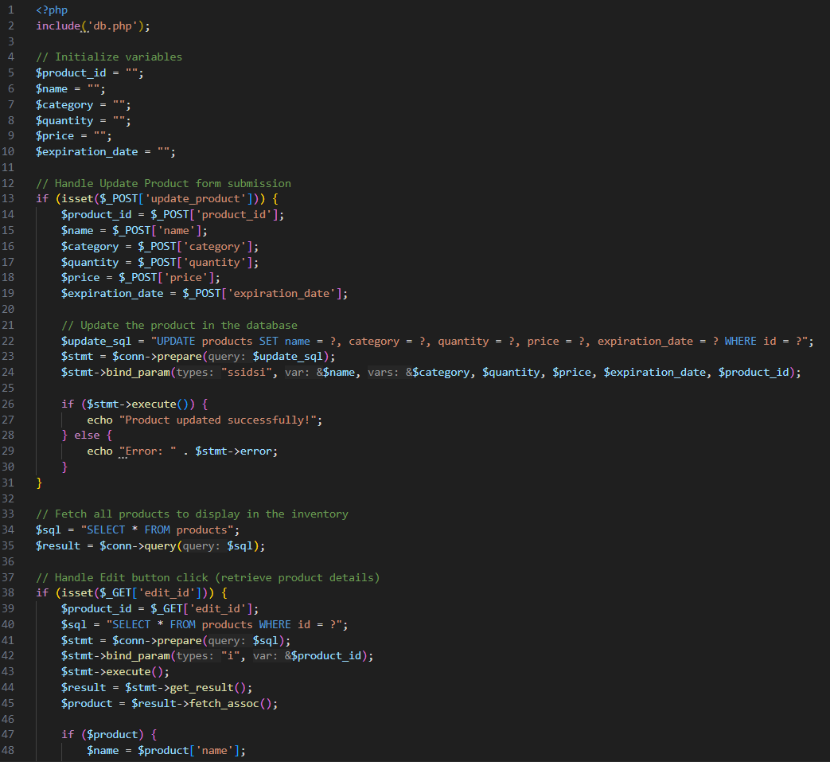inspection in order to further streamline the

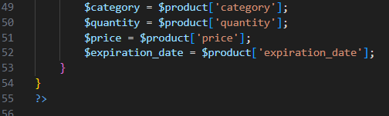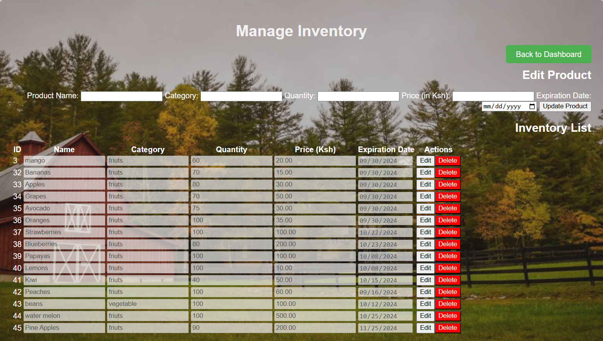The following is the product and inventory for editing and adding products:

Figure 3.3.4-1 logic code for product and inventory management

Figure 3.3.4-2 add and editing products

## 3.3.5 Sales and order functionalities

The code allows for the administration of customer orders, which includes generating detailed receipts and updating inventory. It includes connecting to a database via db.php to handle form submissions in adding new orders, hence providing a seamless way of managing orders and inventories. On form submission, the code pulls out the selected products and their quantities, calculates the total price for each product, and updates the grand total for the entire order. It checks for the availability of the product by comparing the requested quantity with the available stock, thereby preventing orders from being greater than existing inventory. If there is enough stock, it creates an order in the orders table, subtracts the ordered quantity from the products table, and outputs a detailed receipt with order ID, name of the product, quantity ordered, unit price, and the total cost of each item ordered.

It also shows the grand total of all items in addition to print options. If there is insufficient stock for a product, the script will notify users of the shortage. The product names and IDs are fetched to be shown in dropdowns for dynamic product selection. Since the scripting here seamlessly integrates order processing, inventory updates, and receipt generation through its core logic.

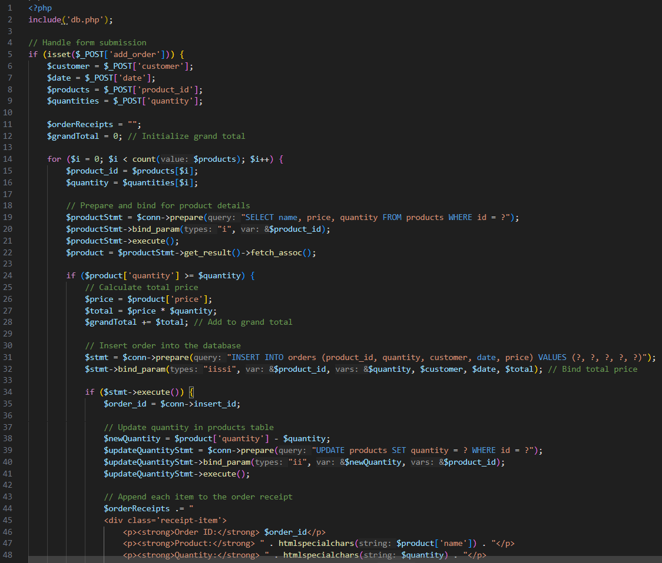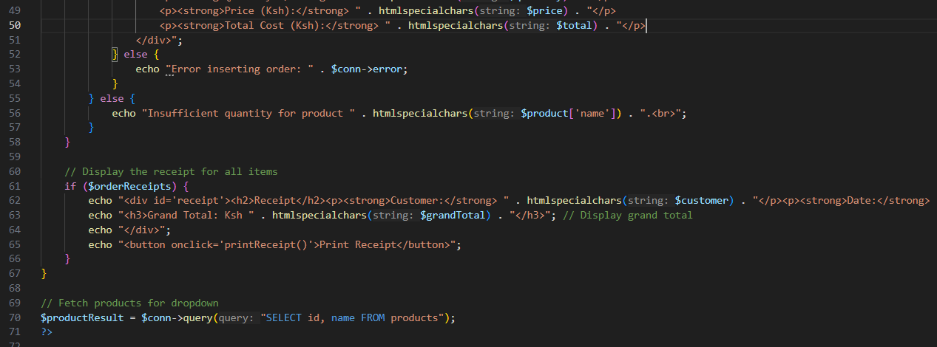

Figure 3.3.5-1 logic code for sales and orders

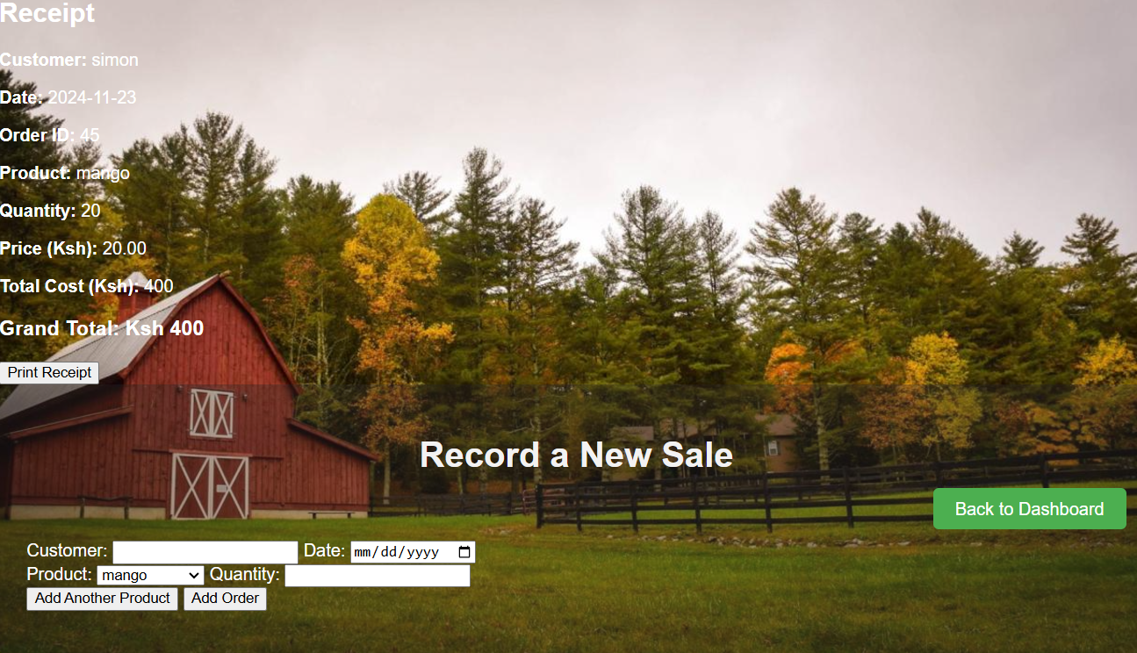The following shows the sales process and receipt printing:

Figure 3.3.5-2 sale and receipt printing

## 3.3.6 Reports functionalities

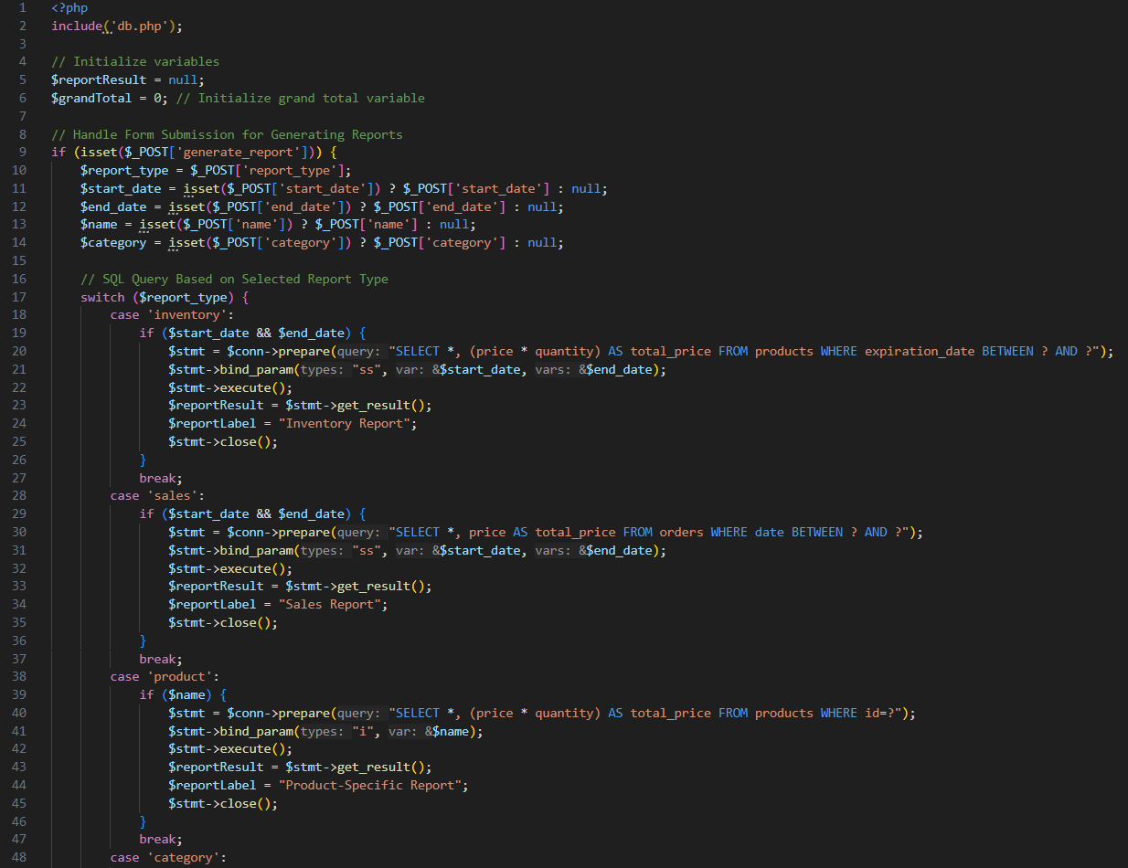This report generation system allows users to generate and print different types of reports based on various criteria. The available report types include **Inventory Reports** (filtered by date range), **Sales Reports** (also filtered by date range), **Product-Specific Reports** (based on a selected product), and **Category-Specific Reports** (filtered by product category). Users can select the desired report type and enter the relevant criteria such as start and end dates, product name, or category. Once the report is generated, it is displayed in a table with relevant data, including quantities, prices, and total amounts. The system also calculates and shows the grand total for the selected report. A **Print Report** button allows users to easily print the generated report, opening it in a new window that formats the content for printing

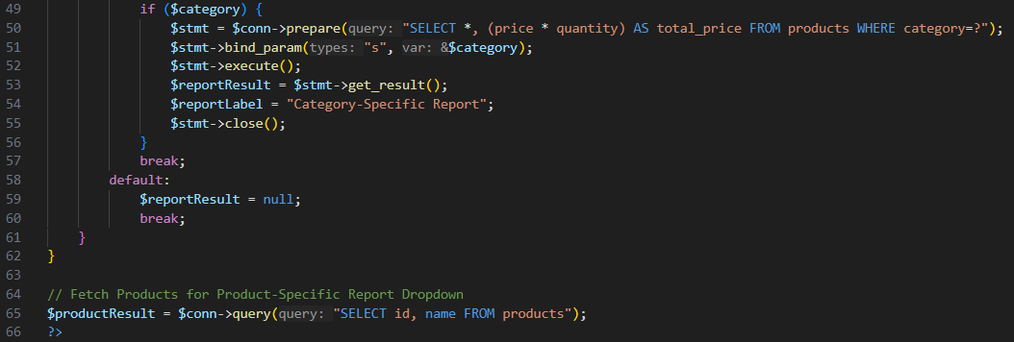

Figure 3.3.6-1 logic code for reports generation

The following is the code for printing the reports:

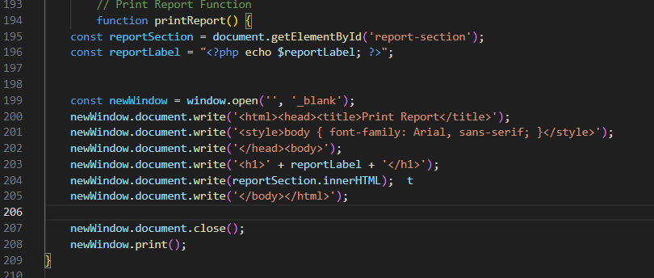

Figure 3.3.6-2 logic code for report printing

The following is the selection of types of reports to be generated:

## CHAPTER FOUR: SYSTEM QUALITY TESTS

Figure 3.3.6-3 reports selection

## 4.1 Introduction

To ensure that everything is working as expected, the following feature tests and DB integration tests were conducted:

## 4.2 User Entry and Validation Test (Feature Test)

This test was performed to verify whether users can enter valid inventory details (such as product names, prices, and quantities), and if the system correctly handles invalid or incomplete inputs.  
*Steps taken to conduct this test:*

1. Open the Inventory Management Dashboard.
2. Click "Add Product" to create a new inventory item.
3. Fill in the product details (e.g., Name: Mango, Category: Fruit, Quantity: 100, Price: 20).
4. Leave one field empty or input invalid data (e.g., duplicate product name, negative quantity).  
   *Expected Output:  
   Correct Output:*

* All fields valid: The product is added to the inventory and saved in the database.
* Invalid product name or empty fields: An error message, such as "Product name must be unique!" or "Field cannot be empty!" prevents submission.  
  *Incorrect Output:*
* The system allows invalid or empty entries to be saved without error messages.

## 4.3 Inventory Update and Auto-Save Test (Feature Test)

This test was conducted to verify if the system updates inventory details (such as quantity and price) and auto-saves changes upon entering valid data.  
**Steps taken to conduct this test:**

1. Open the Inventory Management Dashboard.
2. Select a product and update details (e.g., quantity to 150, price to 25).
3. Leave a field empty or input invalid data (e.g., negative quantity).  
   **Expected Output:**  
   **Correct Output:**

* Valid data is auto-saved in the database, and the updated product details are reflected in the dashboard.
* Invalid or empty fields trigger an error message, and the system prevents changes.  
  **Incorrect Output:**
* Invalid data is saved without error messages or warnings.

## 4.4 Inventory Search and Filter Test (Feature Test)

This test was conducted to ensure that the inventory management system correctly filters products based on various criteria (such as name, category, and price range).  
**Steps taken to conduct this test:**

1. Open the Inventory Dashboard.
2. Use the search bar or category filters (e.g., select "Fruit" category, price range: 10-30).
3. Enter invalid search criteria (e.g., a non-existent category).  
   *Expected Output:  
   Correct Output:*

* The inventory is filtered according to the selected criteria and displayed correctly.
* No results for invalid or non-existent criteria trigger an appropriate "No results found" message.  
  **In***correct Output:*
* The system displays incorrect or incomplete results.
* Invalid search criteria do not show an error or appropriate message.

## 4.5 Database Integration Test: Save and Retrieve Inventory Data

This test was conducted to verify that inventory details are correctly saved to and retrieved from the database.  
*Steps taken to conduct this test*:

1. Add a new product in the Inventory Dashboard: (Product Name: Avocado, Category: Fruit, Quantity: 200, Price: 30).
2. Restart the application and verify that the product appears in the dashboard.  
   *Expected Output:*

*Correct Output:*

Valid details: Data is saved automatically to the database.

|  |  |  |  |  |
| --- | --- | --- | --- | --- |
| id | name | category | price | quantity |
| 46 | Avocado | Fruit | 30 | 200 |

Table 4.5-1 data saved automatically

Invalid or empty fields: Error message "Field cannot be empty or invalid!" prevents proceeding.

*Incorrect Output:*

Data is missing from the database or not reflected in the dashboard upon reload.

## 4.6 Delete Functionality Test (Feature and DB Test)

This test was conducted to confirm that deleting a product removes it from both the user interface and the database.  
*Steps taken to conduct this test:*

1. Add a product to the inventory: (Product Name: Watermelon, Category: Fruit, Quantity: 50, Price: 15).
2. Click the "Delete" button for the product and confirm deletion.
3. Check the products table to verify the deletion.  
   *Expected Output:  
   Correct Output:*

* The product is removed from the interface.
* The product is deleted from the database:

In summary, the above tests and their outputs are as follows:

|  |  |  |
| --- | --- | --- |
| Test | Expected Output | Incorrect Output |
| User Entry Validation | Valid inputs saved; invalid inputs blocked with error messages. | Allows invalid/empty entries to save. |
| Inventory Update | Valid details auto-saved; invalid data blocked. | Invalid data saved without error messages. |
| Inventory Search & Filter | Correctly filters inventory based on selected criteria. | Displays incorrect or incomplete results. |
| Database Save/Retrieve | Inventory details saved/retrieved correctly. | Data is missing or incorrect after reload. |
| Delete Functionality | Product and associated data deleted from both interface and DB. | Data remains in interface/database after deletion. |

Table 4.6 Summary of tests

## CHAPTER FIVE: CONCLUSION AND RECOMMENDATIONS

## Conclusion

Automated Farm Inventory Management System for Njenga's Fruit Farm has been developed and implemented. Users- that is, farm managers, sales representatives, and the administrator-can log in to efficiently manage inventories, track purchases, and charge clients. Due to the enhanced powers of the administrator in managing user accounts, only authorized workers can make significant modifications to the inventory system. The system manages farm operations through its powerful backend features and user-friendly interface. During the development process, challenges arose in setting up the SQL database and its integration with PHP for dynamic pulling and storage of data; all this required learning new concepts right from scratch. Notwithstanding the challenges, the project has achieved the main aim of easing inventory control and improving efficiency in farm operations.

**Recommendation**

This system is definitely far from perfect. Developers looking to enhance the system should consider improving the user interface by incorporating interactive elements such as dynamic graphs for inventory trends, drag-and-drop functionality for product categorization, and real-time notifications for stock updates. Additionally, transitioning from a desktop-based solution to a web-based system could allow access from multiple devices, enabling greater flexibility for users managing the farm remotely. Another recommendation is to optimize system resource usage by implementing logic that updates inventory data in the background, reducing the need for continuous manual input. Furthermore, integrating predictive analytics to forecast stock needs based on historical data and market trends could elevate the system’s utility for strategic planning. By addressing these areas, the system could better serve the diverse needs of the farm’s operations.

**APPENDICES**

**Appendix I: Gantt Chart**

|  |  |  |  |  |  |  |  |  |  |  |  |  |
| --- | --- | --- | --- | --- | --- | --- | --- | --- | --- | --- | --- | --- |
|  | **September** | | | | **October** | | | | **November** | | | **Dec** |
| **Activity** | **Week 1**  **(2nd-6th Sep)** | **Week 2**  **(9th-13th Sep)** | **Week 3**  **(16th-20th Sep)** | **Week 4**  **(23rd-27th Sep)** | **Week 5**  **(30th – 4th Oct)** | **Week 6**  **(7th – 11th Oct )** | **Week 7**  **(14th-18th Oct)** | **Week 8**  **(21st-25th Oct)** | **Week 9**  **(28th-1st Nov)** | **Week 10**  **(4th-8th Nov)** | **Week 11**  **(8th – 15th Nov)** | **Week 12**  **(2nd Dec)** |
| 1. Lecturer’s Introduction to Fundamental Concepts of a Software Project |  |  |  |  |  |  |  |  |  |  |  |  |
| 1. Development of a Work plan |  |  |  |  |  |  |  |  |  |  |  |  |
| 1. Developing U.I. |  |  |  |  |  |  |  |  |  |  |  |  |
| 1. Developing DB |  |  |  |  |  |  |  |  |  |  |  |  |
| 1. Logic implementation with tests |  |  |  |  |  |  |  |  |  |  |  |  |
| 1. Panel presentation |  |  |  |  |  |  |  |  |  |  |  |  |

**Appendix II: Resource Requirement and Economic Feasibility Assessment**

|  |  |  |
| --- | --- | --- |
| **Resource** | **Purpose** | **Cost (Ksh)** |
| *Hardware resources:* | | |
| 1. Laptop / PC | * Develop project (front end, back end, testing) * Presentation | * Already available |
| *Software resources:* | | |
| 1. Vs code | * For writing simple PHP scripts | * Open source |
| 1. XAMPP | * Front end implementation * Logic code writing and testing * In house DB implementation * Running the project files | * Open source |
| 1. SQL | * Setting up an SQL logic environment on the computer | * Open source |
| *Labor:* | | |
| * Development | | * Free |
| **TOTAL** | | **0.00** |

**REFERENCES**

XAMPP installer downloadhttps://www.apachefriends.org/download.html

SQL cheat sheet https://cdn.codewithmosh.com/image/upload/v1702943687/cheat-sheets/sql.pdf

PHP for beginners https://www.youtube.com/watch?v=m52ljs78S24&list=PL0eyrZgxdwhwwQQZA79OzYwl5ewA7HQih